Documentation for TP deliverable
Student members: YU, ZAN

1. Purpose of the deliverable

The provided deliverable allows to estimate camera motion using only 2 views of the observed scene. This is done by a set of functions that tackle subtasks such as detecting 2D key points by calculating SIFT features, matching corresponding key-points by using brute force match, finding fundamental matrix by using cv2.findFundamentalMatrix(), getting the essential matrix by using the fundamental matrix and calibration matrix, getting the rotation matrix(R) and the translation matrix(t) by using cv2.recoverPose() and finally getting camera motion by using the corresponding rotation matrix and translation matrix.

2. Executing the deliverable with default parameters

source /opt/campux/virtualenv/computervision/bin/activate
python3 TP5.py

2.1 Executing the deliverable with specific parameters

GetM is a configuration parameter, it can be set to several cases which decides the result to be print on the terminal:
cases are:
2.1(1) GetM = 1 The fundamental matrix will be shown on the terminal.
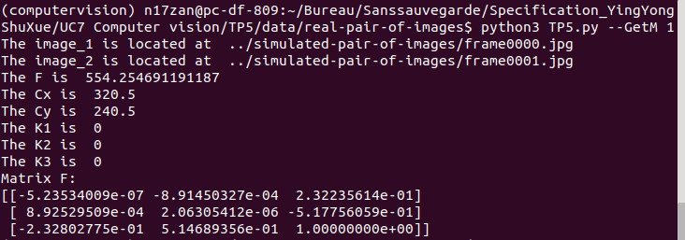

2.1(2) GetM = 2 The fundamental matrix and essential matrix will be shown on the terminal.
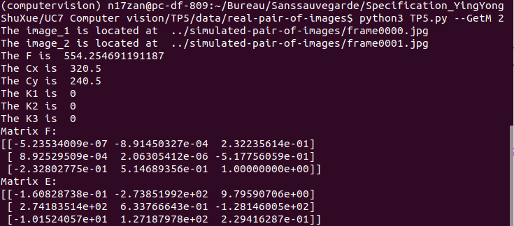

2.1(3) GetM = 3 The fundamental matrix, essential matrix and the C to C_prime extrinsic matrix will be shown on the terminal.
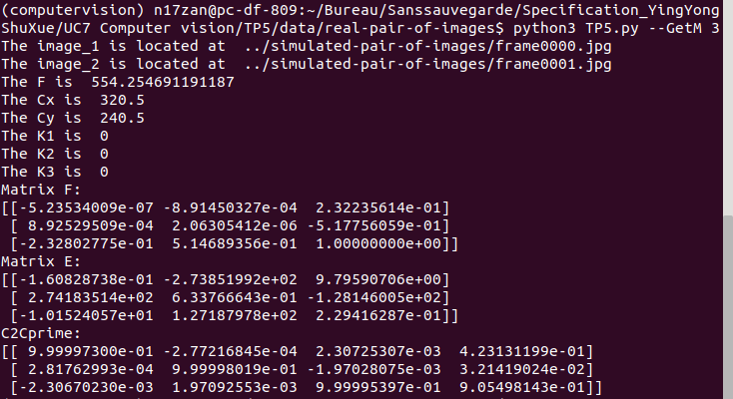

2.1(4) GetM = 4 All the results mentioned in the case 3 will be mentioned, besides the rotation information will also be shown in form as Euler angles.

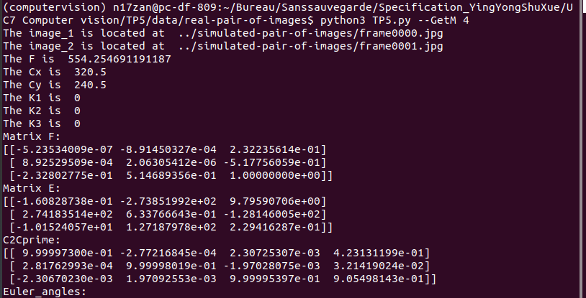

GetI is the parameter to choose whether visualise the epipolar geometry or not, if it takes value 1 then the epipolar lines in both images will be plot.
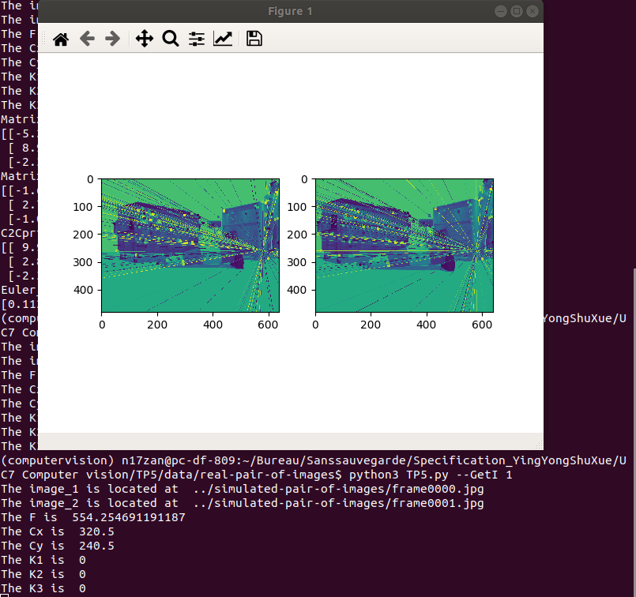

3 Using the deliverable with default parameters

The user should first activate the environment by taping:
source /opt/campux/virtualenv/computervision/bin/activate
Than to execute the programme by taping:
python3 TP5.py
Than the fundamental matrix, essential matrix, camera motion and Euler angle will be shown in the command line.

Ps: If you want to output the two view geometry images, you could type:
python3 TP5.py --GetI 1
If you want to get more information about parameters, you could type:
python3 TP5.py --help

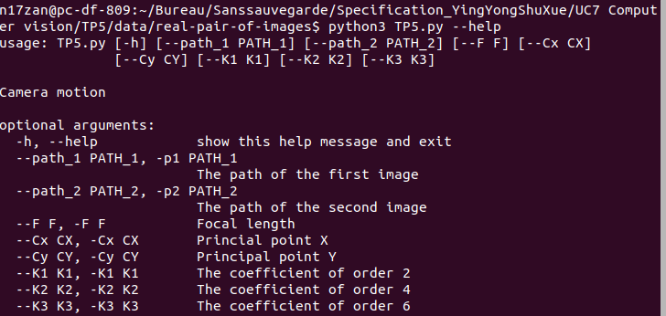
The default value of the parameters are:
--path_1 = '../simulated-pair-of-images/frame0000.jpg'
--path_2 = '../simulated-pair-of-images/frame0001.jpg'
--F = 554.254691191187
--Cx = 320.5
--Cy = 240.5
--K1 = 0
--K2 = 0
--K3 = 0
--GetM = 4
--GetI = 0

3.1 Using the deliverable with specific parameters

To use this script with specific parameters, the user should assign to path_1, path_2 the paths of images of two view. And user should also enter the intrinsic parameters of the camera. Firstly the focal length f and the principal points cx and cy should be given to construct the camera matrix, as for the radial distortion we use the Taylor series approximation to approximate it and we only take into consider the coefficients until order 6, so k1,k2,k3 should be given.

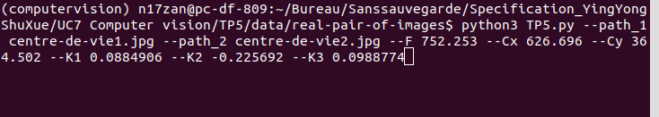
Assaignement of parameters

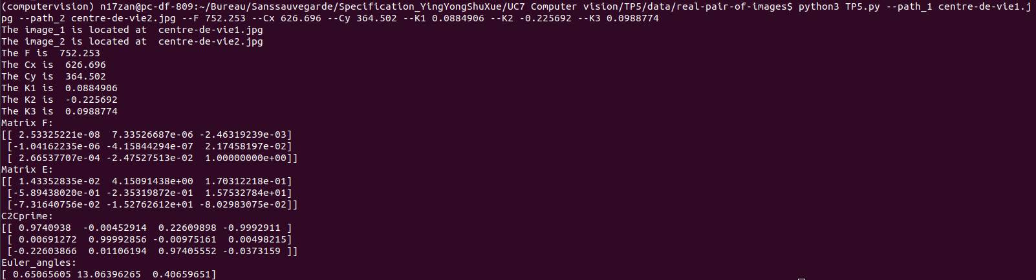
Output results

